Source Code

1. Program.cs

using System;

using System.Collections.Generic;

using System.Linq;

using System.Text;

using System.Threading.Tasks;

/// <summary>

/// PROG2070-17W-Sec4-Programming: Software Quality Assurance

/// Assignment1 - main program

///

/// Yoonsuk Cho #7135551

/// Feb 02, 2017

/// </summary>

namespace YChoAssignment01

{

class Program

{

static void Main(string[] args)

{

bool isCont = true;

int input = 0;

while (isCont)

{

Console.Write("Input Square Side Length: ");

if (Int32.TryParse(Console.ReadLine(), out input))

{

if (input < 1) isCont = true;

else isCont = false;

}

if (isCont)

{

Console.WriteLine("You have got a wrong input!");

}

else

{

Console.WriteLine("Input side length: " + input);

}

clearScreen();

}

Square square = new Square(input);

isCont = true;

while (isCont)

{

Console.WriteLine("1.Get Square Side Length");

Console.WriteLine("2.Change Square Side Length");

Console.WriteLine("3.Get Square Perimeter");

Console.WriteLine("4.Get Square Area");

Console.WriteLine("5.Exit");

Console.WriteLine("");

Console.Write("Please select number (1-5): ");

if (Int32.TryParse(Console.ReadLine(), out input))

{

if (input < 1 || input > 5) input = 6;

}

else input = 6;

switch (input)

{

case 1:

Console.WriteLine("Square Side is {0}", square.GetSide());

clearScreen();

break;

case 2:

Console.WriteLine("Input side length: ");

int sideLength = 0;

if (Int32.TryParse(Console.ReadLine(), out sideLength))

{

if (sideLength >= 1)

{

square.ChangeSide(sideLength);

Console.WriteLine("Square side is changed to {0}", sideLength);

clearScreen();

break;

}

}

Console.WriteLine("You have got a wrong input!");

clearScreen();

break;

case 3:

Console.WriteLine("Square Perimeter is {0}", square.GetPerimeter());

clearScreen();

break;

case 4:

Console.WriteLine("Square Area is {0}", square.GetArea());

clearScreen();

break;

case 5:

isCont = false;

clearScreen();

break;

default:

Console.WriteLine("You have got a wrong input!");

clearScreen();

break;

}

}

}

/// <summary>

/// show message and clear message

/// </summary>

private static void clearScreen()

{

Console.WriteLine("Press any key !");

Console.ReadKey();

Console.Clear();

}

}

}

1. Square.cs

using System;

using System.Collections.Generic;

using System.Linq;

using System.Text;

using System.Threading.Tasks;

/// <summary>

/// PROG2070-17W-Sec4-Programming: Software Quality Assurance

/// Assignment1 - Square module

///

/// Yoonsuk Cho #7135551

/// Feb 02, 2017

/// </summary>

namespace YChoAssignment01

{

public class Square

{

private int side = 0;

/// <summary>

/// default constructor

/// </summary>

public Square()

{

this.side = 1;

}

/// <summary>

/// additinal constructor

/// </summary>

public Square(int side)

{

this.side = side;

}

/// <summary>

/// get side of square

/// </summary>

/// <returns>side</returns>

public int GetSide()

{

return side;

}

/// <summary>

/// change side of square

/// </summary>

/// <param name="side">side to be changed</param>

/// <returns>side changed</returns>

public int ChangeSide(int side)

{

this.side = side;

return side;

}

/// <summary>

/// get perimeter of square

/// </summary>

/// <returns>perimeter</returns>

public int GetPerimeter()

{

return side \* 4;

}

/// <summary>

/// get area of square

/// </summary>

/// <returns>area</returns>

public int GetArea()

{

return side \* side;

}

}

}

1. SquareTests.cs

using System;

using Microsoft.VisualStudio.TestTools.UnitTesting;

using NUnit.Framework;

/// <summary>

/// PROG2070-17W-Sec4-Programming: Software Quality Assurance

/// Assignment1 - Test Program

///

/// Yoonsuk Cho #7135551

/// Feb 02, 2017

/// </summary>

namespace YChoAssignment01.Tests

{

[TestClass]

public class SquareTests

{

/// <summary>

/// test of GetSide method

/// </summary>

[Test]

public void GetSideTest()

{

Square sq = new Square(5);

int side = sq.GetSide();

NUnit.Framework.Assert.AreEqual(5, side);

}

/// <summary>

/// test of ChangeSide method

/// </summary>

[Test]

public void ChangeSideTest()

{

Square sq = new Square(5);

int side = sq.ChangeSide(4);

NUnit.Framework.Assert.AreEqual(4, side);

}

/// <summary>

/// test of GetPerimeter method

/// </summary>

[Test]

public void GetPerimeterTest()

{

Square sq = new Square(5);

int side = sq.GetPerimeter();

NUnit.Framework.Assert.AreEqual(20, side);

}

/// <summary>

/// test of GetPerimeter method

/// </summary>

[Test]

public void GetAreaTest()

{

Square sq = new Square(5);

int side = sq.GetArea();

NUnit.Framework.Assert.AreEqual(25, side);

}

}

}

Screen Shot of Git

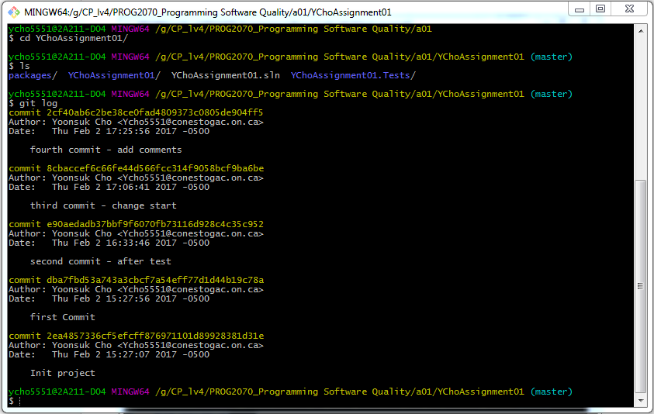

Screen Shot of Test

